**RAMTHAR VENG YMA LIBRARY SOFTWARE DOCUMENTATION**

**USERS REGISTRATION & LOGIN**

1. Login and Register page (Landing Page)



1. Registration Process :

When you click Register located Right Corner of landing page, you have to enter the Software code to proceed for users registration. Here you can create administrator’s privileges only.

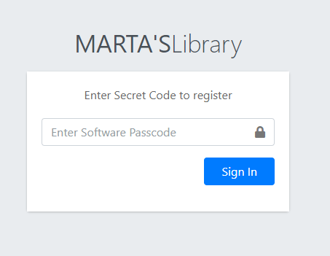

1. Users Registration:

Steps to create users:

1. **Full name:** You have to select/choose user name and it will be used as Display Name.
2. **Email:** You can use dummy or existing email addresses which have a correct email format (eg. [xxx@email.com](mailto:xxx@email.com)). This email address is used for login credentials.
3. **Password:** You can create any word or phrase not less than 8 characters. This password is used for login credentials.
4. **Retype Password:** You have to enter exactly the same as you have entered in the Password field.

Click on Register button to register the new users. Make sure Full Name and Email is not already registered.

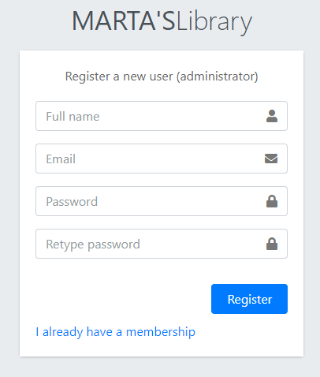

1. Login:

When you click Login located Right Corner of landing page, you have to enter the details you have entered during Users Registration.

1. **Email:** Enter your email address that you have entered during registration.
2. **Password:** Enter your password that you have entered during registration.
3. I forgot my password: When you forgot your password, you can retrieve through this link and provide a valid email address. **But this link is useable only when your domain have supported a mail services only**.

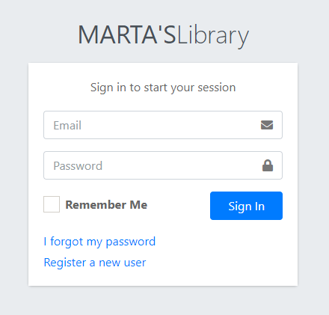

***Note:*** *1) When you login with the administrator privilege user, you can create another user as well as you can change the password or other details of the users.*

**DASHBOARD**

1. After you Login to the system, first page is the Dashboard. Here, you can have many functions and information one click away. Lets dig in.

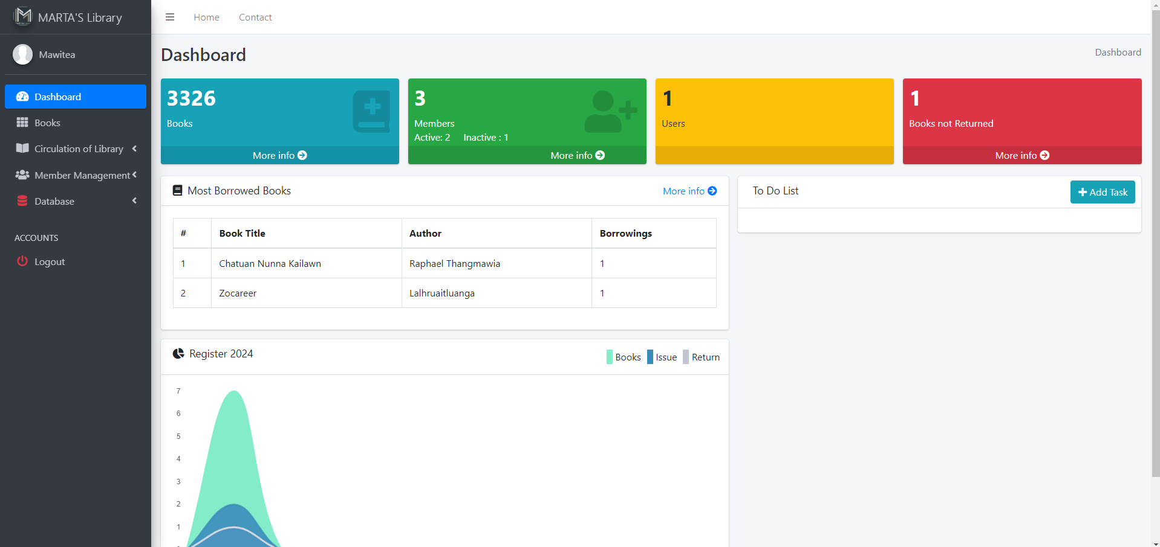

1. 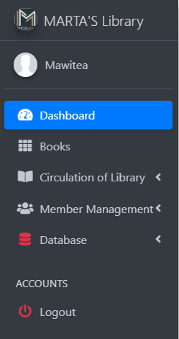Menu:

Menu is located at the left side of the page.

1. **Library YMA:** This enable to navigate to a landing page.
2. **User:** This will navigate you to a page where you can edit your users details.
3. **Dashboard:** It will navigate to Dashboard page.
4. **Books:** It will navigate to a page where you can create, view, search, edit and delete books.
5. **Member Management:** It will navigate to a page where you can create, view, search, edit, give rating and delete members, Member ID Card print, sort member rating list, List out inactive users and activating/renew of membership.
6. **Circulation of Library:** It will navigate to a page where you can Issue Book, Return Book, View Receipt of Late Fees Payments, Print Books Code(Bar Codes or QR Codes) and Transactions (Returned and Lending books).
7. **Back Up:** It will back up all the database and save it to your PC.
8. **Logout:** It will logging you out of the system.
9. Information tab:

Information tabs are located at the top of a Dashboard page.

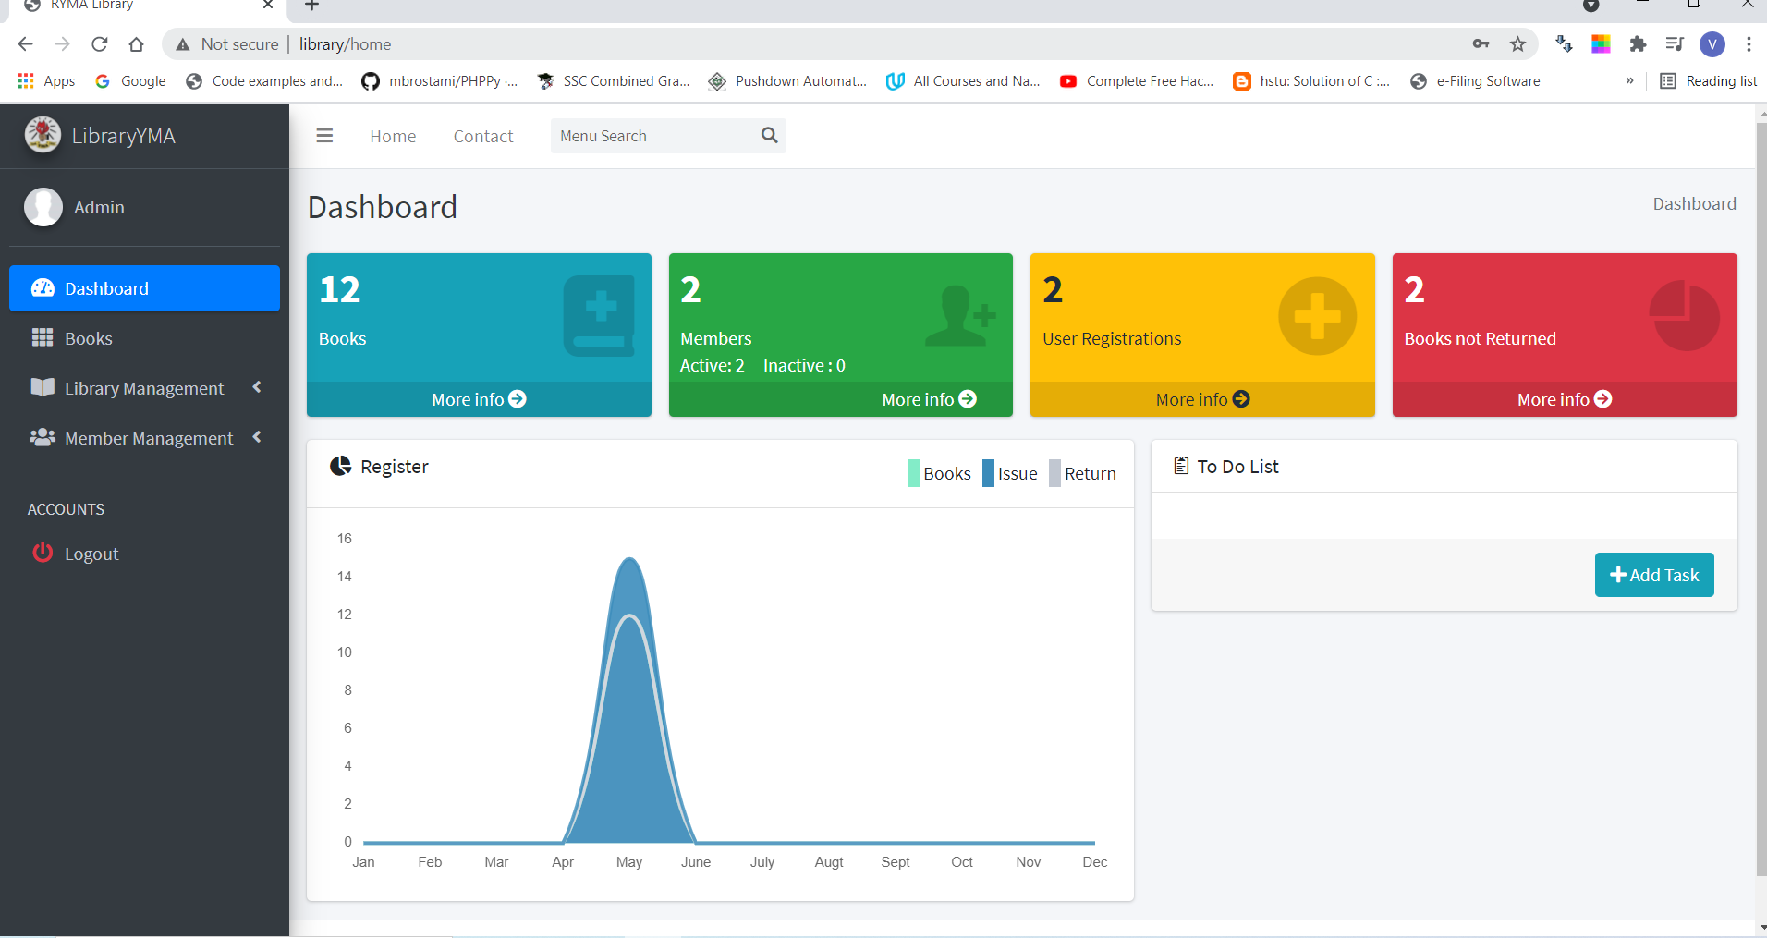

**Books not return**

The red info tab represents Number of books that is on loan and still not returned by members.

More info link will navigate you to a page where you can return a book.

**USER**

The yellow info tab represents Number of users.

Circle with Plus sign icon is a link to enter new users. This icon appears only with the Admin user.

More info link will navigate you to view, search, edit, create and delete users page. **You can reset users password.**

**MEMBERS**

The green info tab represents Number of members. The number appears in the left corner is total members is active and inactive.

Image with Plus sign icon is a link to enter new Members.

More info link will navigate you to view, search, edit, create and delete members page.

**BOOKS**

The blue info tab represents Number of books.

Book with Plus sign icon is a link to enter new books.

More info link will navigate you to view, search, edit, create and delete books page.

1. Registers:

The register is a graphical representation of Total Books, Total Issue and Total Return of lending books of a year per month. Total number of books is represented by the green color line, Total issue is represented by the blue color line and the Total return is represented by the grey color line. The highest line color will be used as the background color of the graph.



1. To Do List:

The To Do List is acting as a note book which you can write some information or notes and delete when done.



1. When Clicking ***Add Task*** button, it will open a pop up dialog box where you can enter your important notes.

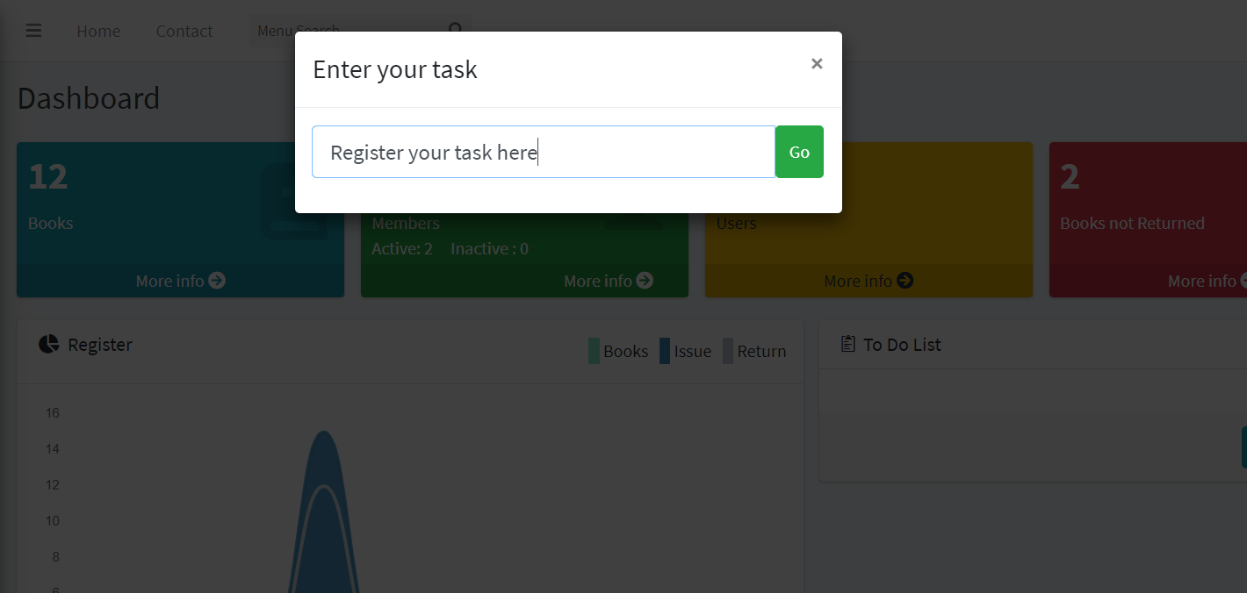

1. When you want to delete your task, point the mouse to the task and ***Delete*** button will show up, and click the Trash button.

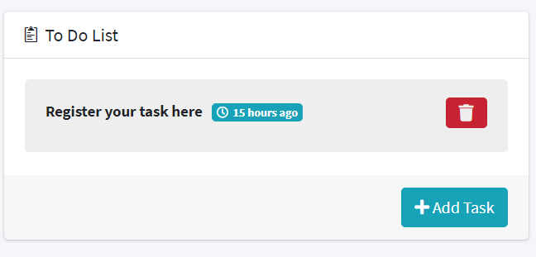

1. Menu Search Bar:



1. **3 horizontal Line**: The 3 horizontal lines are used to toggle Side Bar Menu Hide/Show.
2. **Home**: This link is used for directing to Dashboard.
3. **Contact**: This navigates to About the Software and Software developer details. It can be viewed only from the Dashboard page.

**BOOK ENTRY & BOOK MENU**

1. When you click on Books Menu, Books Page will open. Here you can view list of books, search, edit, delete and enter new books.

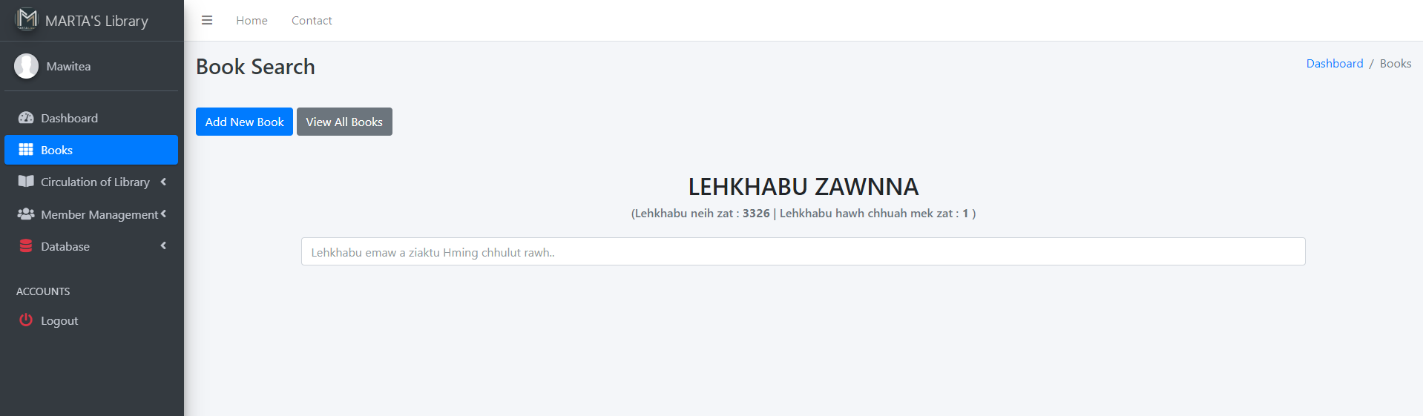

1. You can view all the books record in the form of a table by clicking ***View All Books*** button

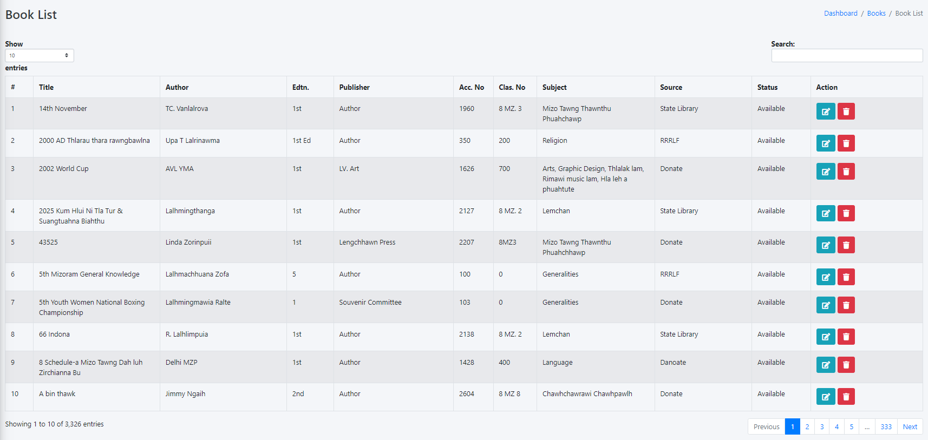

1. Show and Search modules:
2. **Show entries**: This enables you to select number of Books shows in one page; you have 10, 25, 50 and 100 options to choose.
3. **Search**: You can search any column of the table by typing into the Search text fields. It will list out on the table if the text you type is match with the content of the table.
4. Adding Books Procedure:
5. **Add New Book**: This ***Add New Book*** button is used to create a new book to the system.

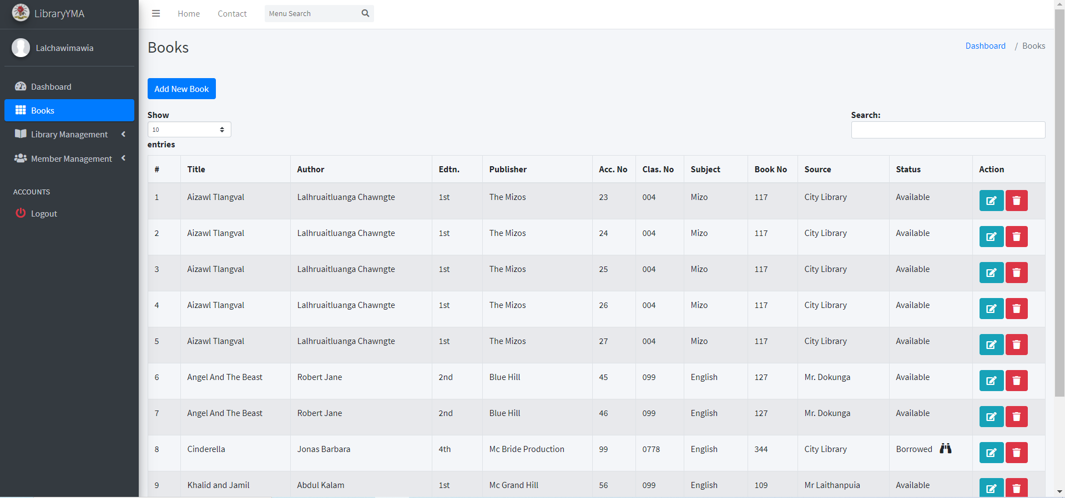

1. **Add Books**: Add Books page is navigate after clicking the ***Add New Book*** button.

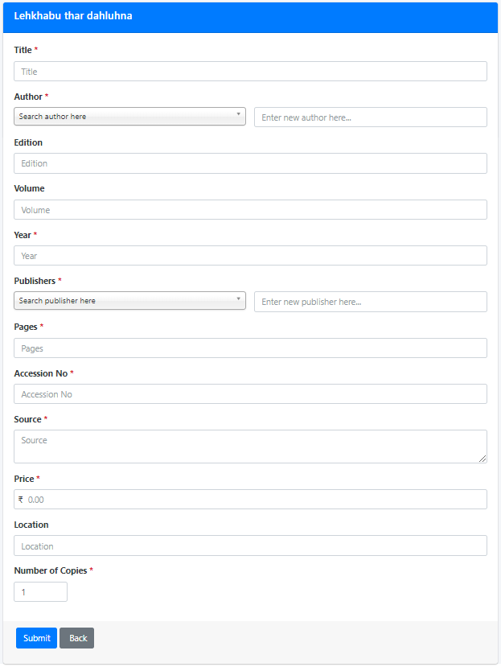

1. **Title**: Enter the Book Title here
2. **Author**: Enter the Author of the Book in the text field if not already entered, else select the author from dropdown list.
3. **Edition**: Enter the edition of the Book here, Just the edition(eg. 1st, 3rd, etc)
4. **Year**: Enter the publishing year of the book
5. **Publishers**: Enter the publisher of the Book in the text field if not already entered, else select the publisher from dropdown list.
6. **Pages**: Enter the number of page of the book.
7. **Accession No**: Enter the accession no, this accession number cannot be same as another. So make sure it is unique before entering.
8. **Volume**: Enter Volume No as Library guidelines.
9. **Subject**: Enter Subject to describe the Book itself (eg. Mizo, English, Science, etc.)
10. **Source**: Enter Source of the book whether it is donated or buy by the Library. Mention the donator name only.
11. **Price**: Enter Price of the book.
12. **Location**: Enter Location as Library guidelines.
13. **Number of Copies**: The default value is 1. When you enter only one book, you do not need to modify. But to enter more than one copies of the same book, you can enter the number of copies and enter only once.

After entering all the fields, click on ***Submit*** button to create new book to the system.

*Note: 1) All the red star fields are required. So, fill the entire text field.*

*2) Most of the error will be pop up.*

*3) Before entering books into the system, issue and return cannot be done.*

1. Edit Book details:

In the list of book table, the last column i.e. Action has a button. The blue button of Action column is used to edit an individual book.

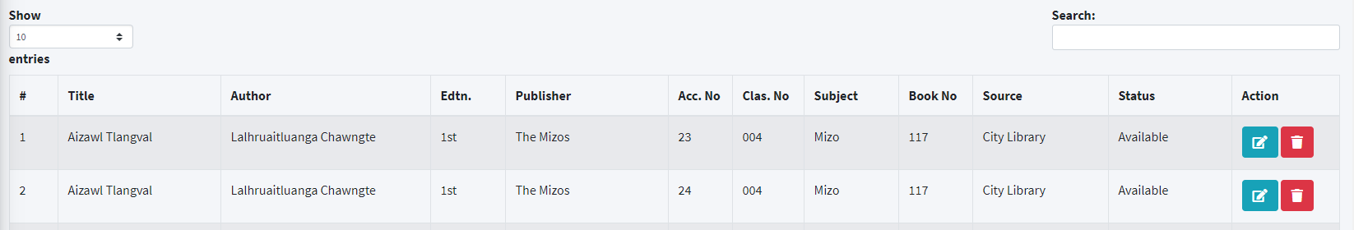

1. When edit button is clicked, it will navigate to an edit page.

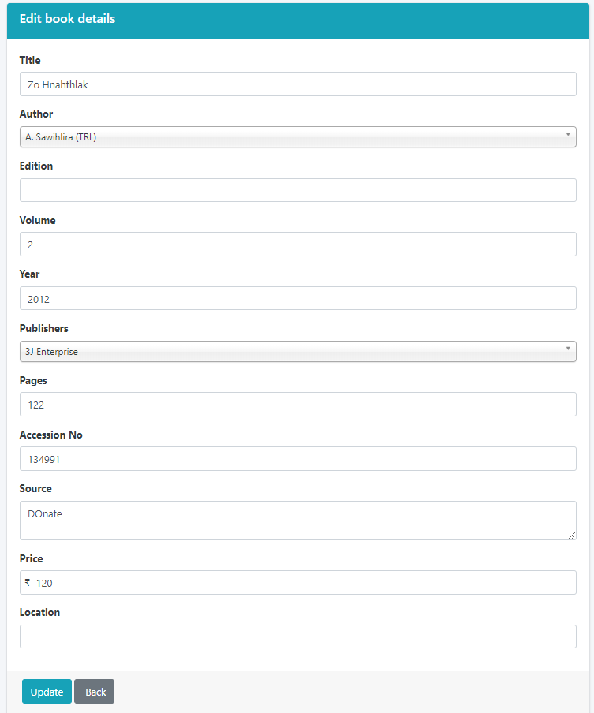

1. After making changes to the fields as required. Click on ***Update*** to Save the changes made.
2. Delete Book:

In the list of book table, the last column i.e. Action has a button. The red button of Action column is used to Delete an individual book.

1. 
2. Click on the trash button (Red button) to delete an individual book record. A confirm popup message will show.

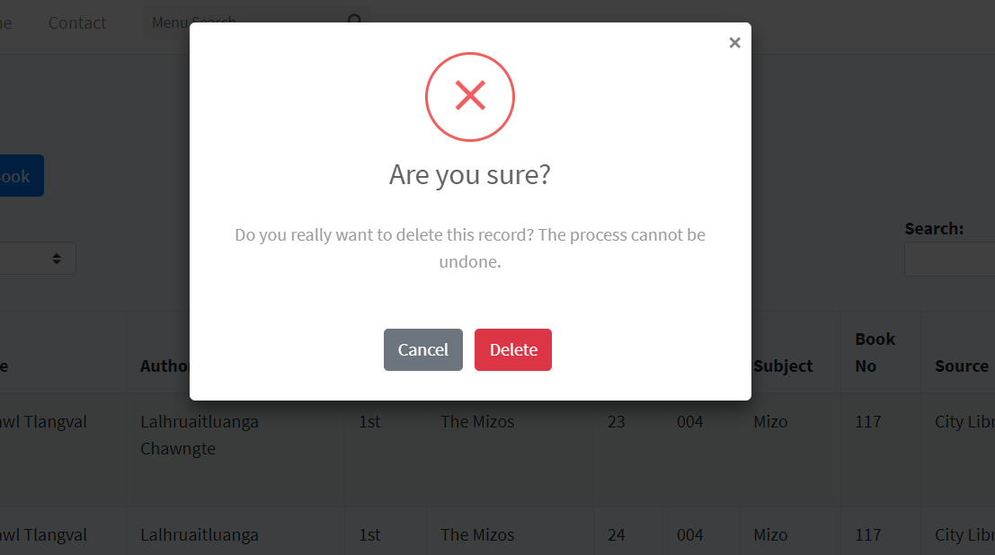

1. Click on ***Delete*** to completely remove the book record from the system. But there is no undelete button or recover deleted books option.

*Notes: i) Before deleting a book from a system, you must be sure the book you have selected to delete is purely necessary or required as the book is damage or lost.*

*ii) Books which are still out for lending cannot be deleted. To delete those book which are still out on lending, you need to returned from the Return Section.*

6. Book Status:

The Book Status is located at the second last column of the Book table, Available are those available at the Library for lending and borrowed are those out from Library and details of **Borrower** and **Issuer** of books borrowed is shown when move mouse pointer over the binocular icon.



**MEMBER ENTRY & MEMBER MANAGEMENT**

When you click on Member Management Menu, it will breakup and shows its Sub-Menu: Member, ID Card, Rating List and Inactive Users.

When you click on Member Menu, Member Page will open. Here you can view list of members, search, edit, view member transactions, delete and enter new members. The book is listed in alphabetic order by its Title.

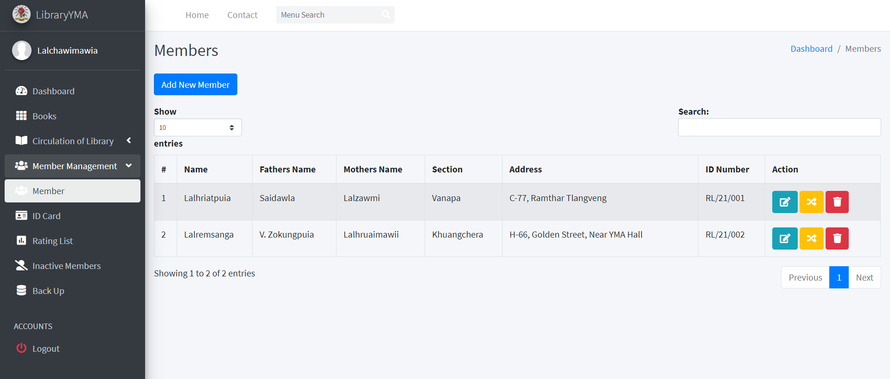

1. **Adding Member Procedure**: Click on the ***Add New Member*** button located in the left top corner of the page. The following page will open.

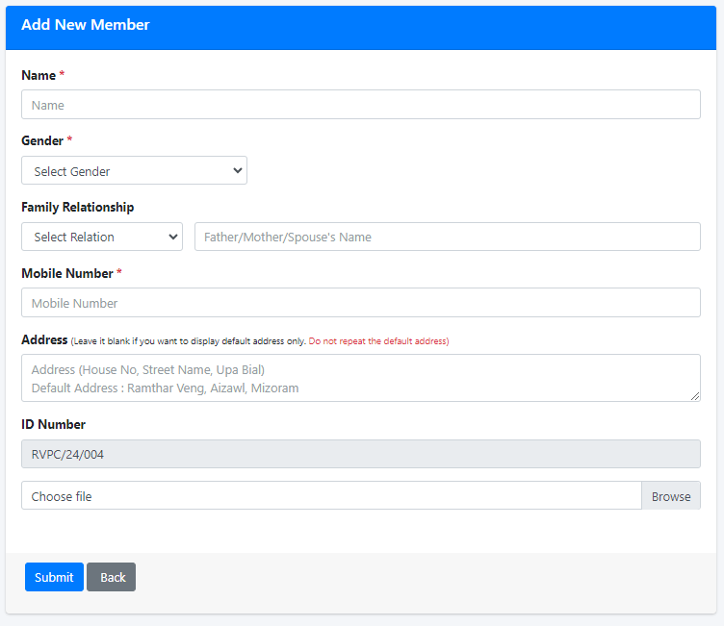

1. **Name**: Enter the member name. Write in a proper order as this will appear in the ID Card as you entered here.
2. **Gender**: Select the gender of a member from dropdown list.
3. **Family Relationship**: Enter the relationship if available, this fields are not mandatory.
4. **Mobile Number**: Enter mobile number of a member or where the member can be contacted. Enter only numerical is allowed with a digit of 10.
5. **Address**: Enter address of the member. Here you have to enter House No, Street Name or building name which can specify the location of members’ resident. You do not need to enter the default Resident Address which you can preset through settings **Default ID Value** .
6. **ID Number**: ID Number is auto generated as suggest by the Library Committee. No need to edit, you can edit the prefix from setting **Default ID Value** .
7. **Choose image**: You can choose a members image by clicking ***Browse*** button to it. This image will be shown in the ID Card of a Library. The image should be clear and well posted, you have to crop the image for clear picture and it will not exceed 2 Mb in size. If image is not selected, a default image of undefined figure will appears as image of the member, this can be change afterwards.

After filling all the necessary fields Click on ***Submit*** button to create new member.

*Note: 1) Since there can be a common name among the members, entering multiple name is enabled, so make sure you do not enter duplicate members as the system did not keep track on duplicate members.*

*2) Creating of member is necessary in order to make issue of books.*

*3) The ID given to member is permanent. So, in order to renew the membership, the same ID will be assigned to its member renewed.*

1. Edit Member details:

In the list of member table, the last column i.e. Action has a button. The blue button of Action column is used to edit an individual member.

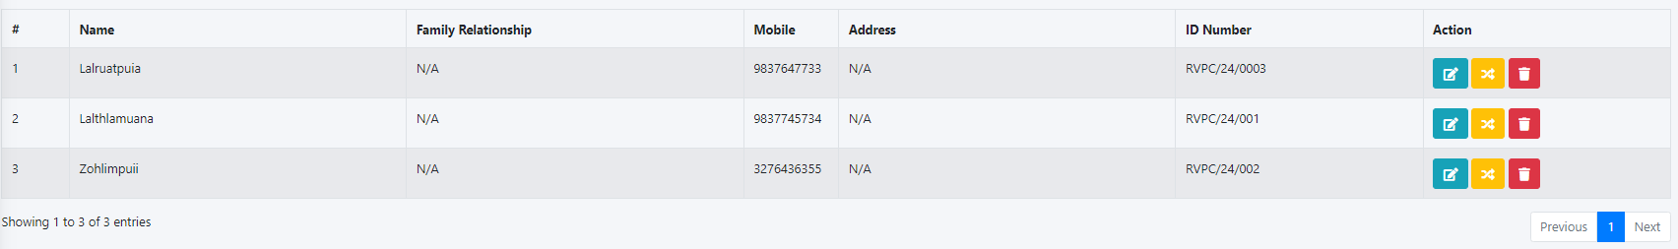

When Edit button i.e. the blue button is clicked, it will navigate to a member edit page.

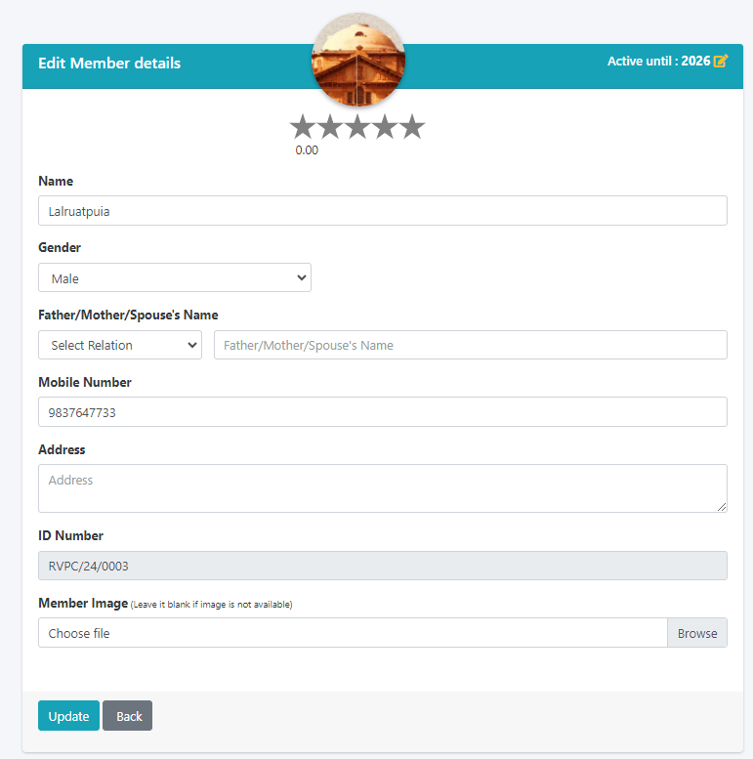

1. **Star Rating**: Star Rating of a member can be made by moving mouse pointer over the grey star and left click when desired position is reached. The rating will highlighted in yellow stars as well as in numbers just below the stars with a label of Rating.
2. **Change member image**: In the last field of a form, click on Browse and select image of a member. This will override the existing image and the old image cannot be taken back.
3. **Extend Membership Validity**: At the right hand side of the top corner, an admin user can extend the membership validity.

After entering or making changes of the information. Click on ***Update*** button to save the changes.

*Notes: 1) You can make rating several times for one member, the users who give ratings (the latest) is registered and displayed.*

*2) Changing of ID Number is not suggested as there might be severe problem regarding the previous transactions.*

*3) Changing of member image multiple times is accepted, but when new image is uploaded, the old image is deleted permanently.*

1. Member Transaction:

In the list of member table, the last column i.e. Action has a button. The yellow button of Action column is used to view transaction (Borrowing of books and Returning of books) of an individual member.

When Transaction button i.e. the yellow button is clicked, it will navigate to a Transaction of a members page.

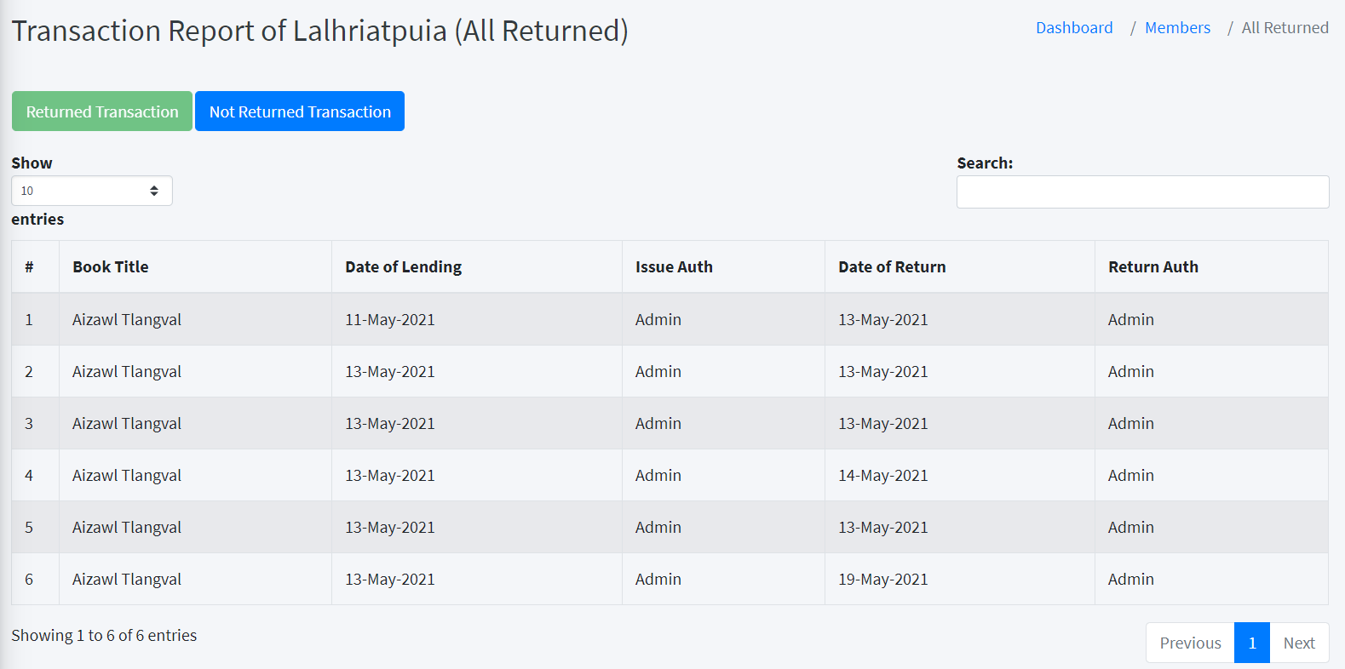

1. The first transaction page contain All Returned Books that the member has made. It will shows every transaction, date of book he borrowed, Date of Return and the Books he have borrowed.

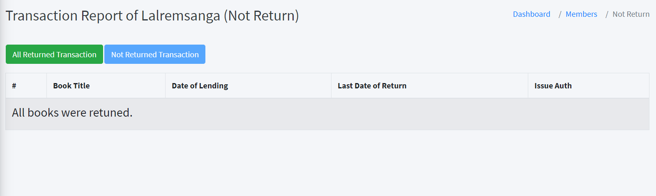

1. When clicked on the Blue button i.e. ***Not Returned Transaction*** button it will navigate to Not Return Transaction Page which will list all the transaction that is still exists. That is the member is still borrowing the books and did not return the books.
2. Delete member:

In the list of member table, the last column i.e. Action has a button. The red button of Action column is used to delete an individual member.

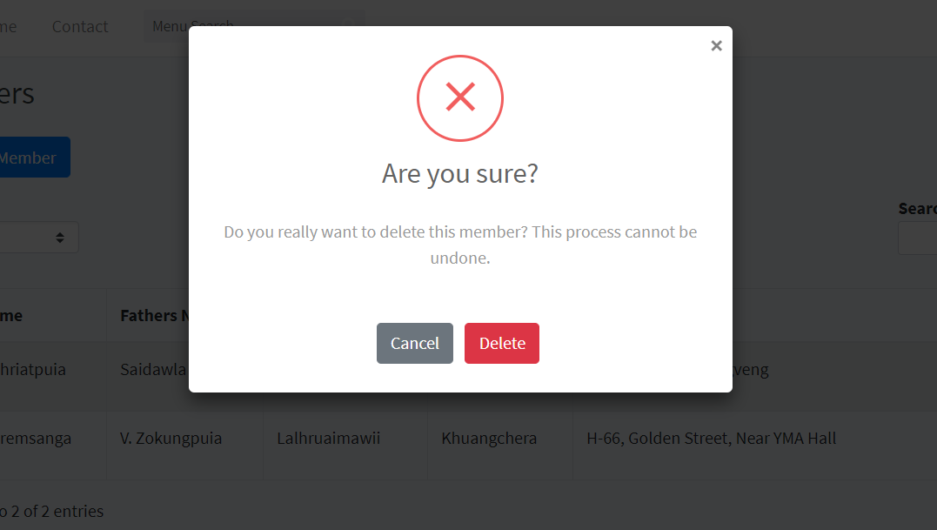

After clicking the trash button or the Red button, a popup will appear. If you click ***Delete***, the member will delete from the system and all the records will also be gone. This process cannot be undone.

If you try to delete a member who still have a books to return, then the delete could not be proceed. In order to delete the member, you have to return all the books borrowed by the member.

**ID CARD GENERATION**

When you click on Member Management menu it will open a sub menu. From the sub menu Click on ID Card and Generate ID Page will open. Here you can view all the active members. Members are listed in alphabetic order by its Name.

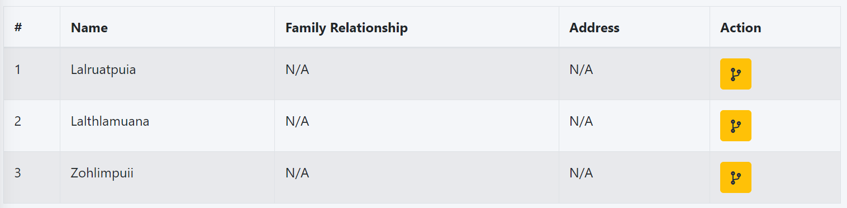

Clicked on the yellow button under the Action column, then it will open the ID Preview Page.

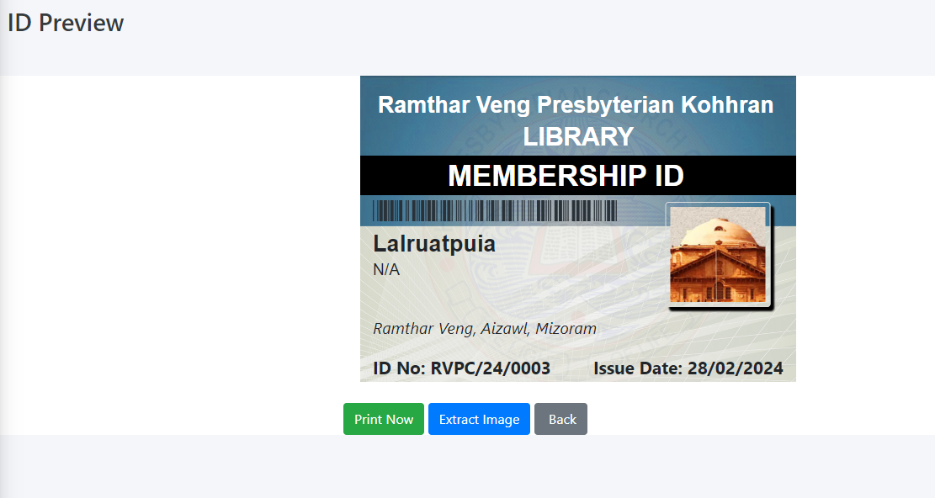

You can click on ***Print Now*** button to print if the member details and images are correct.

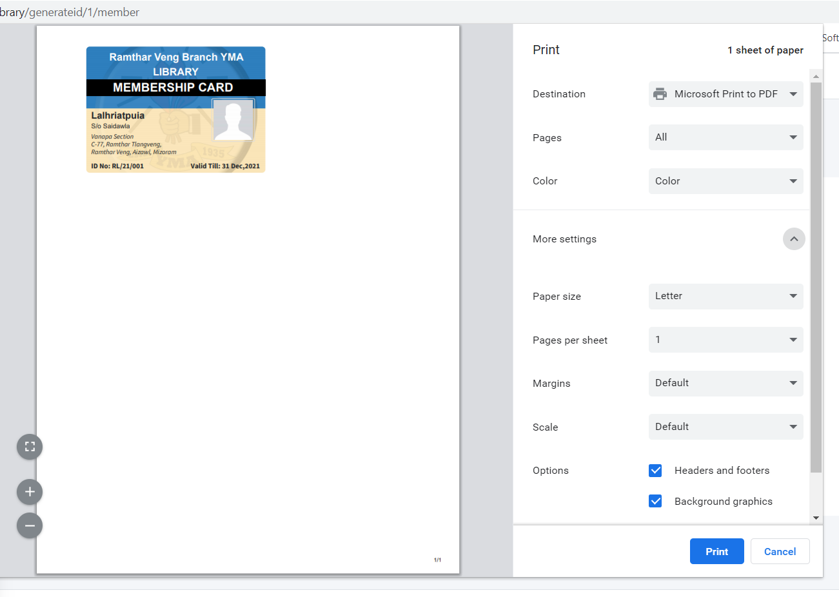

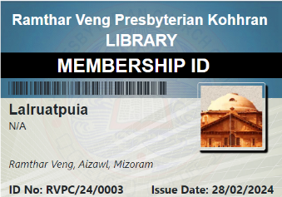

If you do not find the graphic of ID is correct. Then you have to select the Background graphic check mark from the Right pane of print option and unselect the Headers and footers for undisturbed output. Make any other changes if necessary.

**MEMBER RATING LIST**

When you click on Member Management menu it will open a sub menu. From the sub menu Click on Rating List and Ratings of Members Page will open. Here you can view all the ratings of members. Members are listed in descending order by its Ratings given by the users.

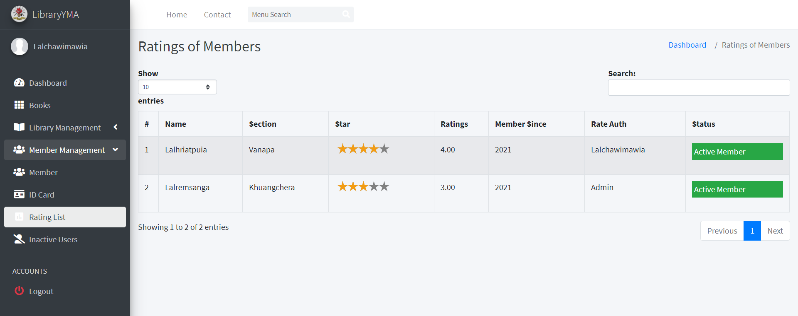

You can search an individual member from the search bar or by the rating numbers given by the users.

You can also sort the order by clicking tin the column name e.g. click on Rating column header will change the list of descending order to ascending order and vice versa.

**INACTIVE MEMBERS/ACTIVATING MEMBERS**

When you click on Member Management menu it will open a sub menu. From the sub menu Click on Inactive Users and Inactive users Page will open. Here you can view all the inactive member. Members are listed in descending order by its Ratings given by the users.

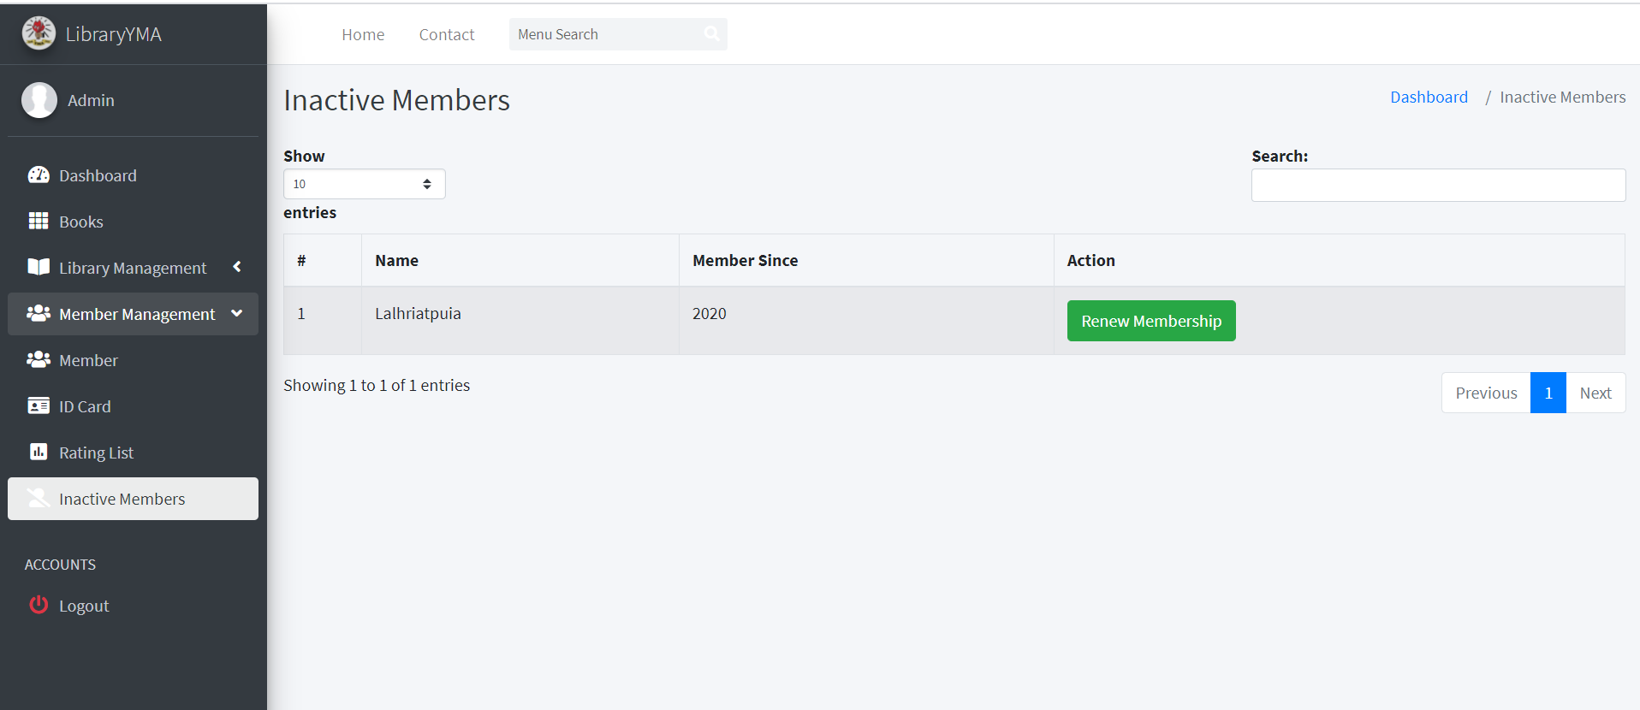

To activate the inactive members, you can click on the green button i.e. ***Renew Membership*** to renew the membership for the current year. You can search an inactive members by its name or Id number from the search bar.

**CIRCULATION OF LIBRARY**

When you click on Circulation of Library Menu, it will breakup and shows its Sub-Menu: Issue Section, Return Section, Receipt Check and Report.

1. PROCEDURE OF ISSUE BOOKS

When you click on Issue Section, Issue Book Page will open. Here you can view list of active members and Issue Book in the Action column. The member name is listed in alphabetic order by its Title.

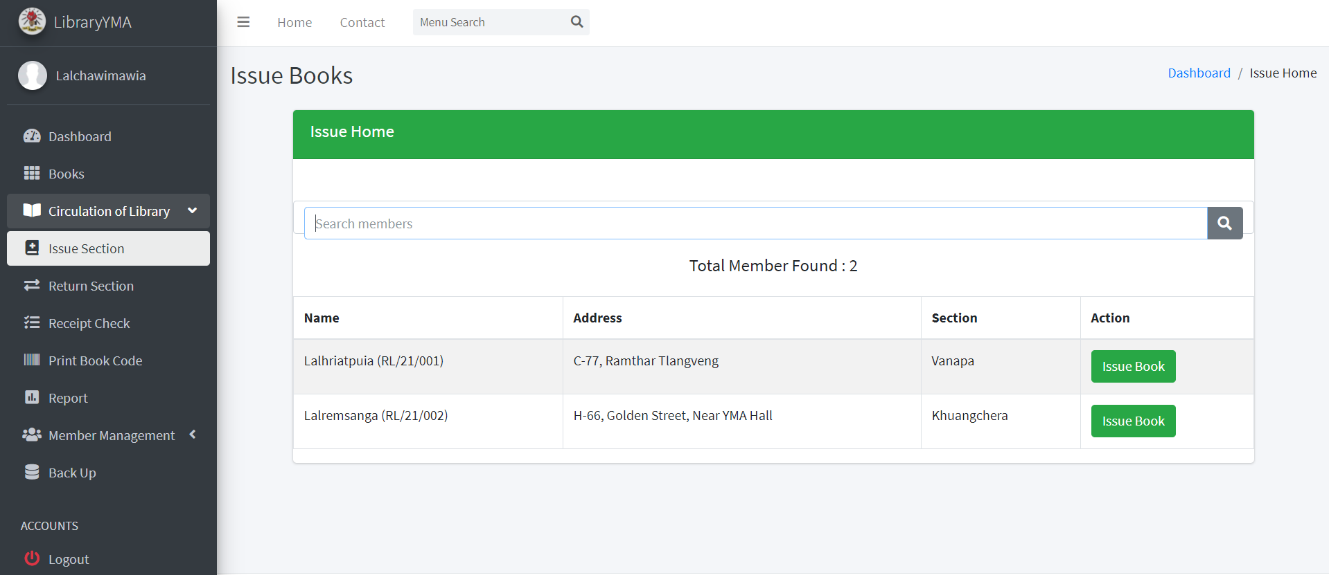

1. The search field i.e. Search members field is used to search by member name and Member ID only.
2. Click on ***Issue Book*** button or the green button of a member that you want to issue books.

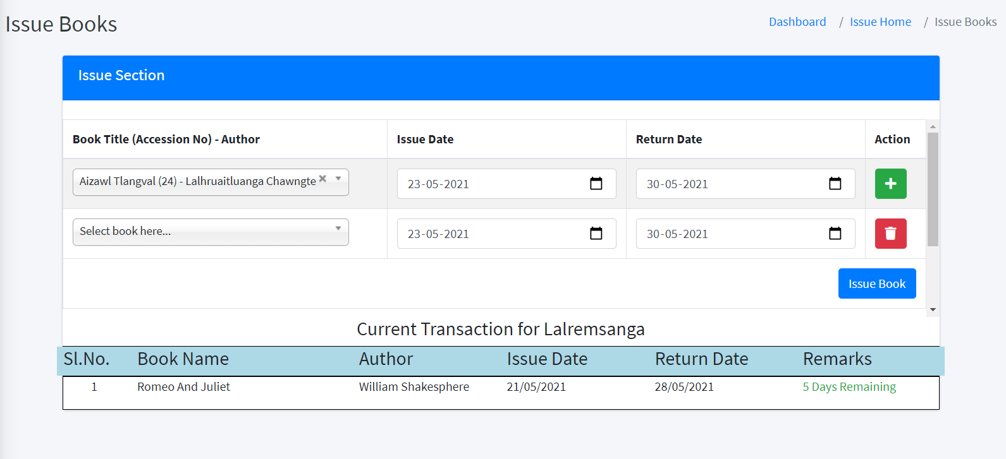

1. An Issue Section page will open, here we have two sections: The Book selection pane i.e located at the top part of the page and The Transaction List Pane i.e located at the bottom of the page.
2. At the Book Selection pane, we can search the book we can to issue by – Book Title, Accession No or Book Author by Just typing it to *Select book here…* dropdown list and select the book with a mouse pointer.
3. The *Issue date* and *Returned date* are set automatically, you can change if necessary.
4. The last column i.e. Action column has a ***Plus*** icon button which enables you to issue more than one book at a time.
5. After selecting all the books that is to be issued, click on the ***Issue Book*** button or the blue button, and all the books selected are now issued to the member.
6. These issued books were automatically displayed in the *Transaction list* as soon as you press the ***Issue Book*** button. By default, 3 books can be issued to one user and the ***Issue Book*** button is disabled when *Transaction list* reaches the limit. You can set the limit and duration of loan period from **Settings->Issue Policies**.

*Note: i) The Transaction List pane display only the current borrowings of the member.*

1. **PROCEDURE OF RETURN BOOKS**

When you click on Return Section, Return Book Page will open. Here you can view list of active members and Issue Book in the Action column. The member name is listed in alphabetic order. You can return the books in two ways: (i) Return Using Member (Borrower) or Member ID (ii) Return Using Book (Borrowed) or Accession Number.

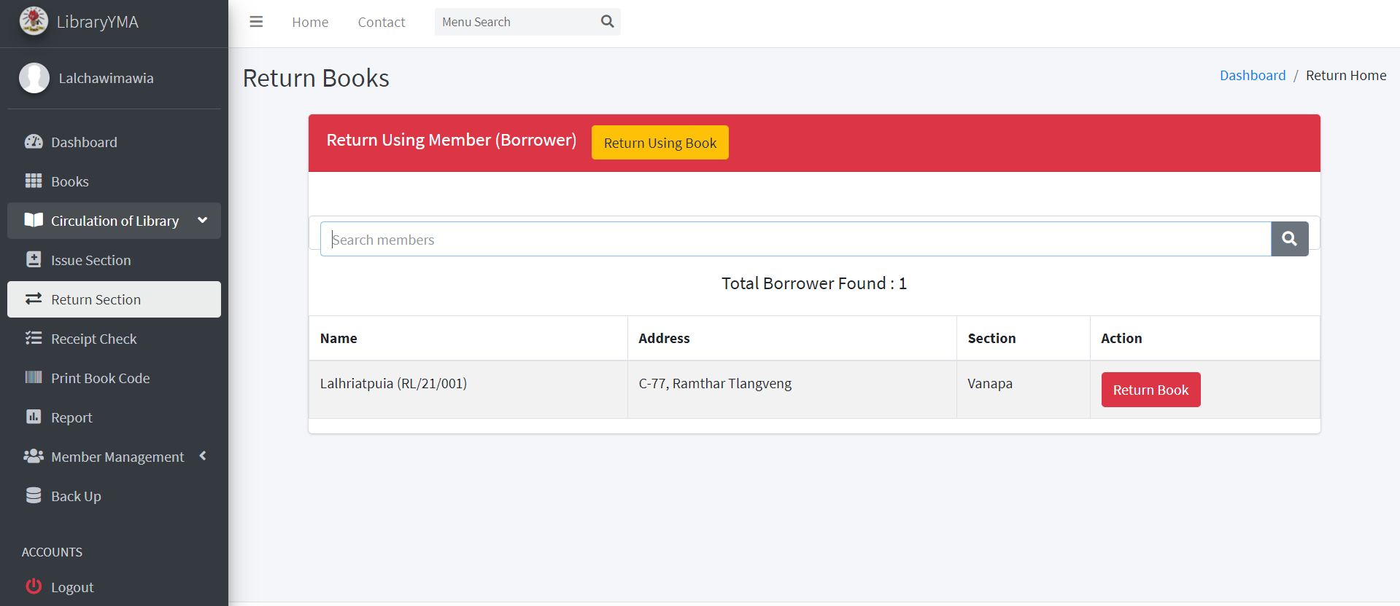

(i) **Return Using Member (Borrower) or Member ID**: This is the First Page that opens when you click Return Section from the menu.

1. The search field i.e. Search members field is used to search by member name and Member ID only.
2. Click on ***Return Book*** button or the red button of a member that you want to return books with.

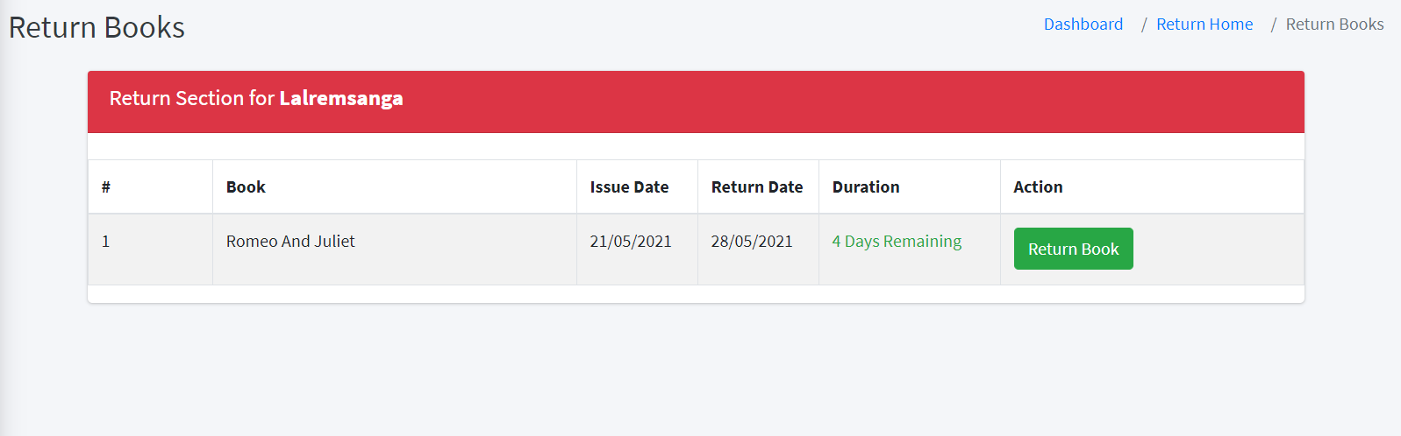

1. The list of borrowed book of a member will be shown. You can Click the ***Return Book*** button or the Green button to return the particular book.
2. You can have another option or output in this page as the book might not be returned during the period given. So, it will prompt the day of returning days with a button to pay a Late Fees i.e ***Pay Fine*** button.

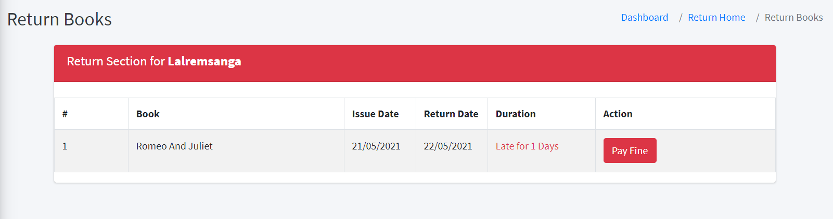

1. To return the books which are late for return date, Click on the ***Pay Fine*** button and it will bring up a pop up page.

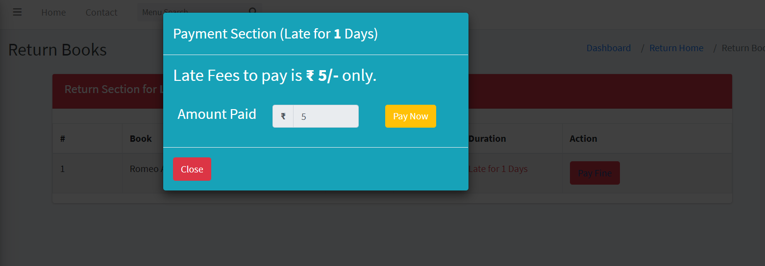

1. If the late fees is paid, then click on ***Pay Now*** button. To cancel the payment, click on ***Close*** button (It will not enable to return the book that is late to return when you click on ***Close*** button). If you want to make discount, you can enter the final amount in the textbox.

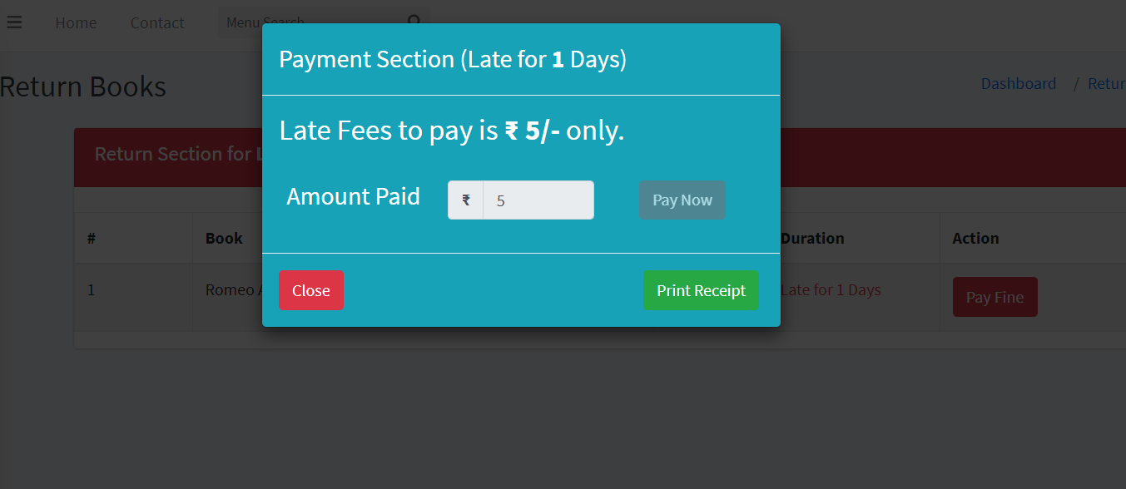

1. After Clicking ***Pay Now*** button, A new button ***Print Receipt*** will appear at the right bottom corner. Click on a ***Print Receipt*** button to acknowledge and print out the late Fee payment receipt.

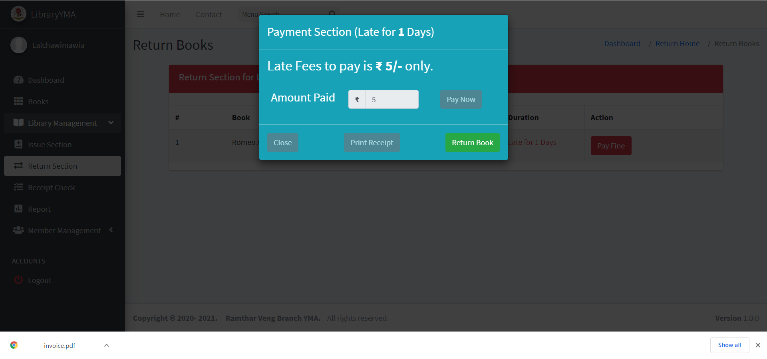

1. After pressing the ***Print Receipt*** button, the receipt will automatically downloaded as **Receipt.pdf** and will be stored on your PC Download folder.

Then a new button ***Return Book*** will appear. Now, you can Click on ***Return Book*** to return the book that is late for return.

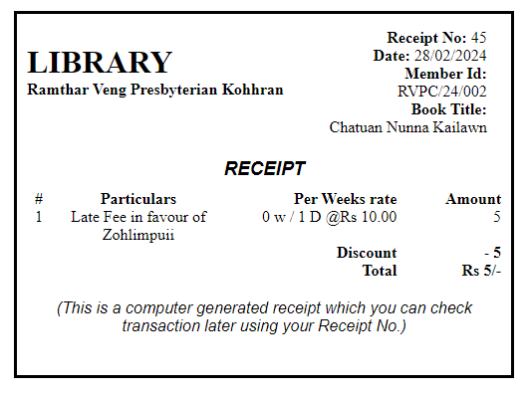

1. If you open the downloaded **Receipt.pdf**, you will find the details about the payment of late fees. You have to note down the Receipt No which is located on the Top Right Corner for further references. Receipt can be verify and recheck from Receipt Check menu item.

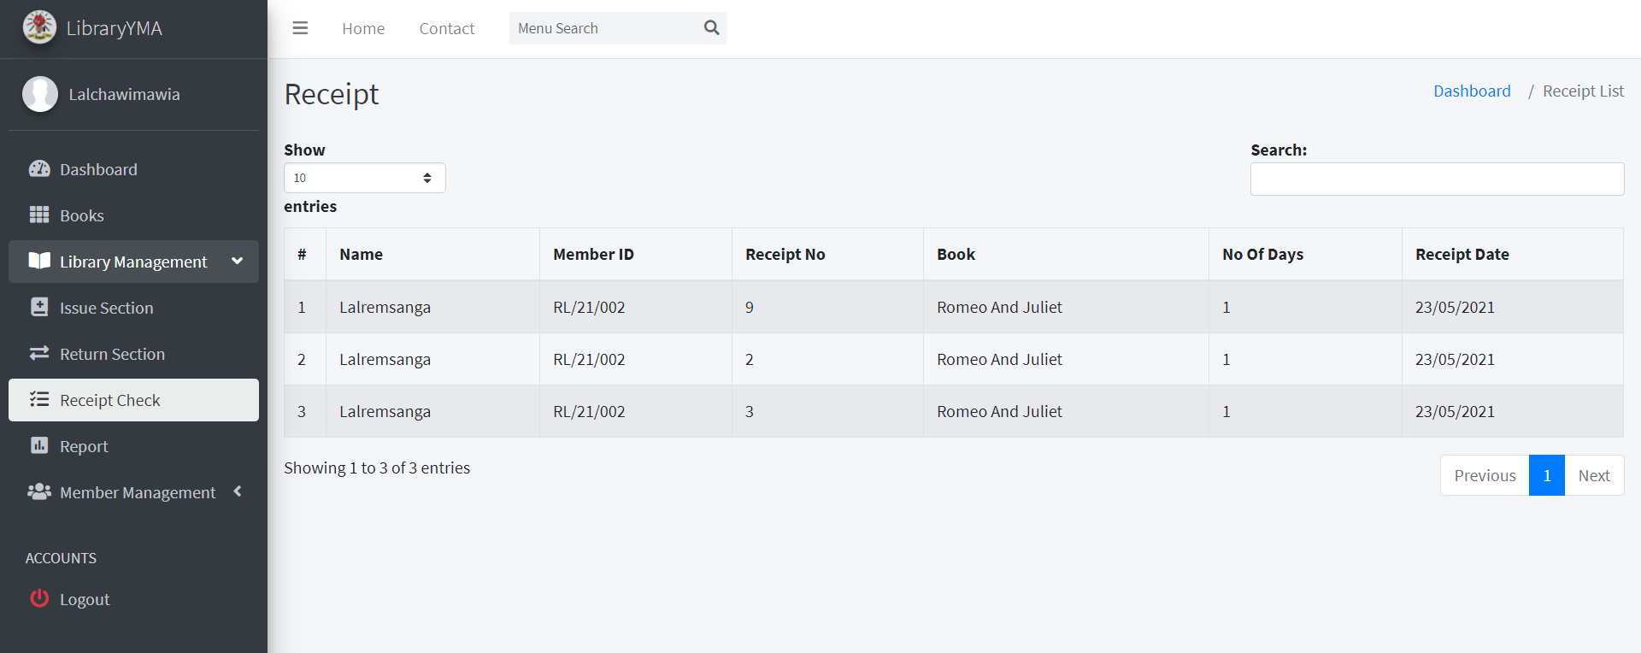

1. **PRINT BOOK CODE**

Print Book Code Display all the recorded books with a ready to print its code. You can print the book code as Barcode format or QR Code format. You can also print multiple code.

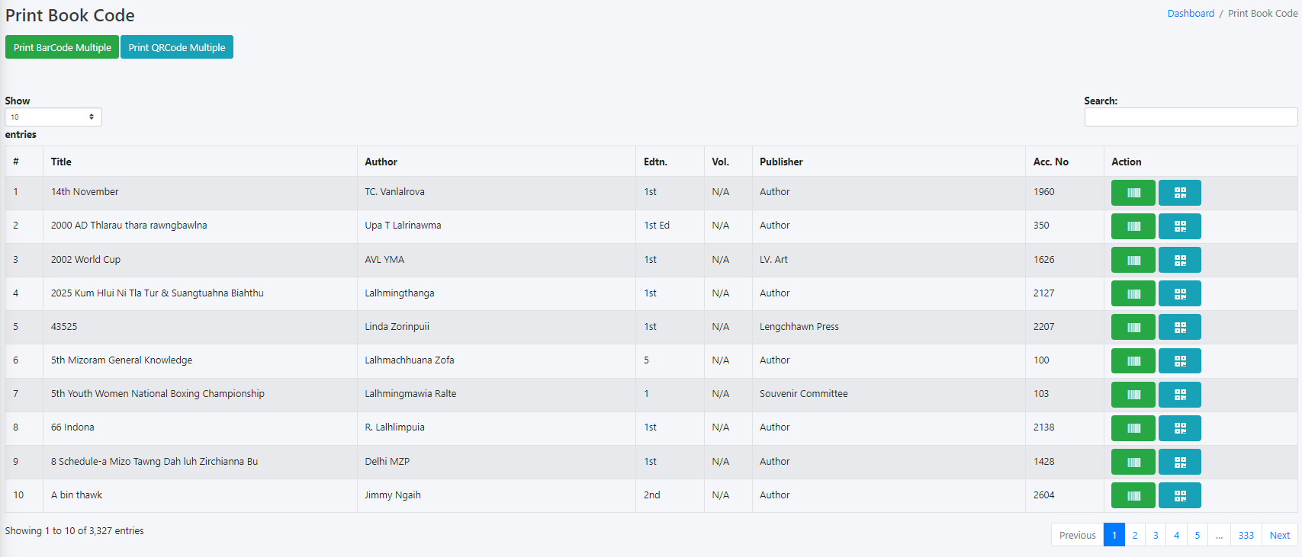

To print Barcode of a book, you can click on the Green Button under the Action column.

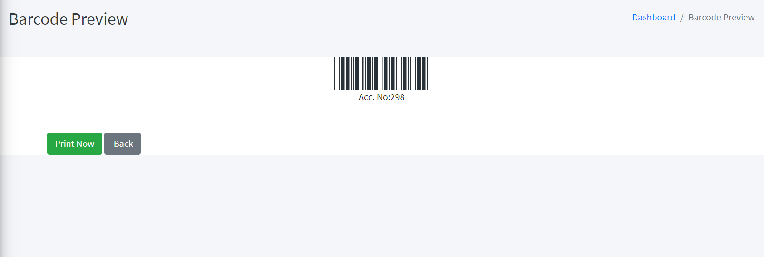

To print QR code of a book, you can click on the Blue Button under the Action column.

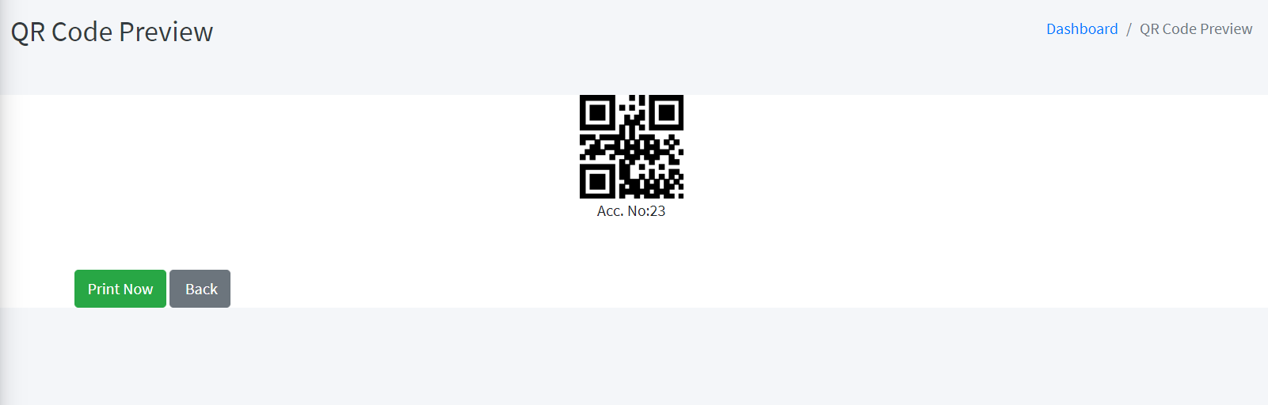

Click on **Print Now** button and you can paste the printed code to the book associated. Then this code can be used use for further search the book as follows:

1. **How to use in Book Menu**: Put the cursor or Click the mouse pointer to the Search Text Box, which is located just above the right corner of the table. Scan the code that is pasted in the book with a Barcode or QR Code scanner, then the Accession Number of the book will automatically appears in the search fields and will list out the book in the table.
2. **How to use in Issue Section**: After clicking to **Issue Book** button, and the Issue Section opens, click on Select Book here… and scan the code that is pasted in the book with a Barcode or QR Code scanner, then the Accession Number of the book will automatically appears in the search fields and will list out the book in the table.
3. **How to use in Return Section**: After clicking to **Return Using Book** button, and the Return Book page opens, scan the code that is pasted in the book with a Barcode or QR Code scanner, then the Accession Number of the book will automatically appears in the search fields and will list out the book in the table.

You can also print a consecutive accession number of a books using the ***Print Multiple*** button which is located at the top left of the page.

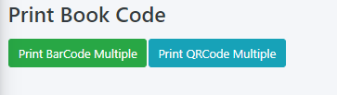

When you click a ***Print Multiple*** button, a new page will open and in that new page you can enter the starting accession number of a book you want to print the code. By default, the bar code will generate a range of 65 books starting from the input and QRCode will generate 24 books starting from the input given.

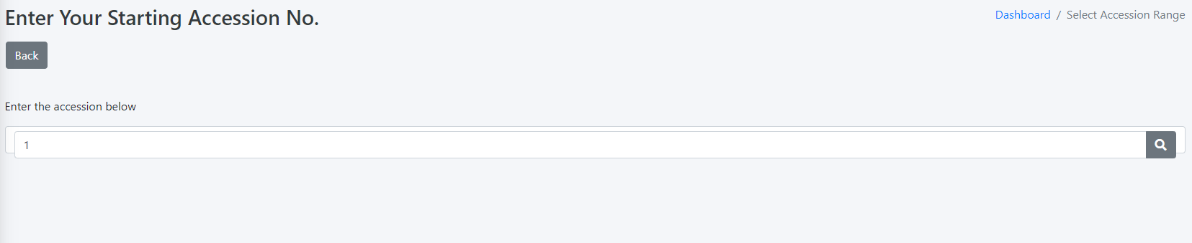

The list of books will be displayed and all are selected. If you want some books to be excluded to print, you can unselect from the corresponding checkbox. Click on the ***Print Bar Code*** button to print the selected books.

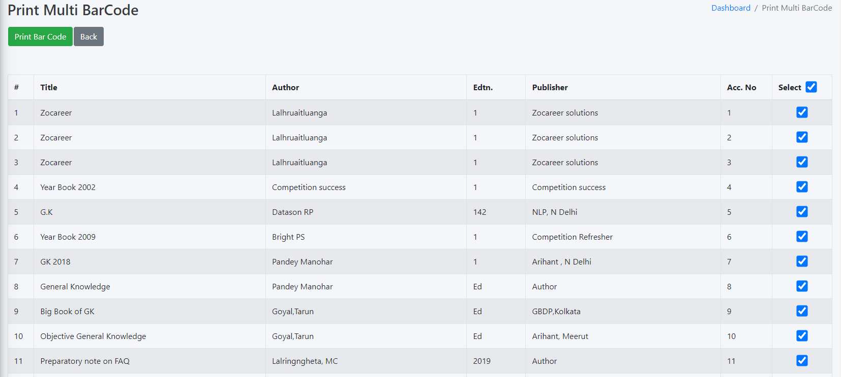

1. **REPORT**

Report page acts as a register of a Library. It shows all the transaction made. It contains two page i.e. a) Books Issue & Return Report (Returned) b) Books Issue & Return Report (Not Returned)

1. **Books Issue & Return Report (Returned)**: Here all the finished transaction i.e. borrowed and returned books are shown with Book Title, Borrower, Issue Date, Issuing Authority, Return Date and Return Authority. You can use Search box to sort the table on relation to any column.

*Eg.* The Title Column contains the Book Title with the Accession number, the accession no is shown inside the bracket. Type the Title name on the Search box will result in bringing out the exact Title of a book present in the table automatically, or type the Accession Number in the search box will show only a row that have the accession number entered. And so on.

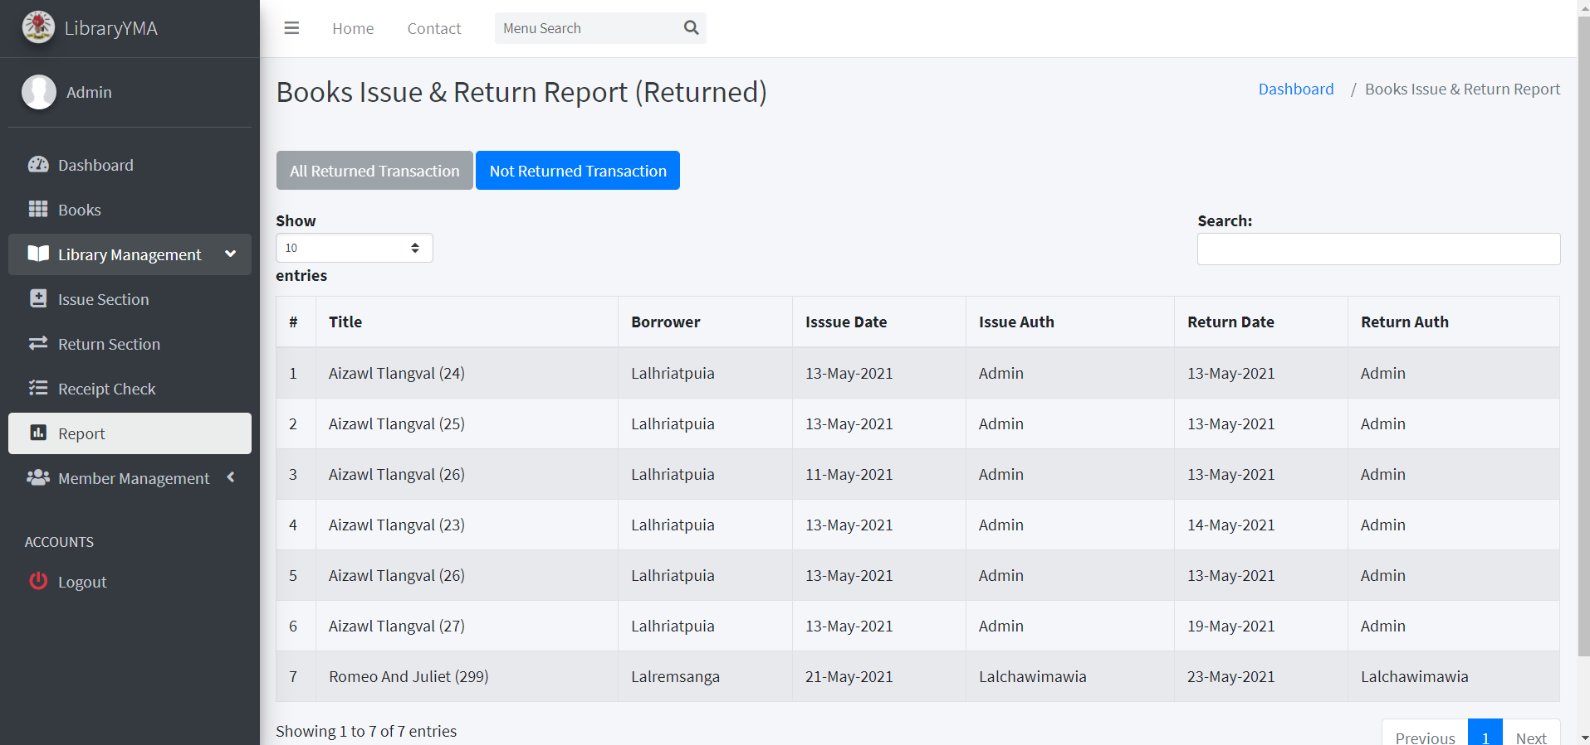

1. **Books Issue & Return Report (Not Returned)**: Here all the Issued transaction, borrowed but not returned books i.e. books that are still borrowed by members are shown with Book Title, Borrower, Issue Date, Issuing Authority, Return Date and Return Authority. You can use Search box to sort the table on relation to any column.

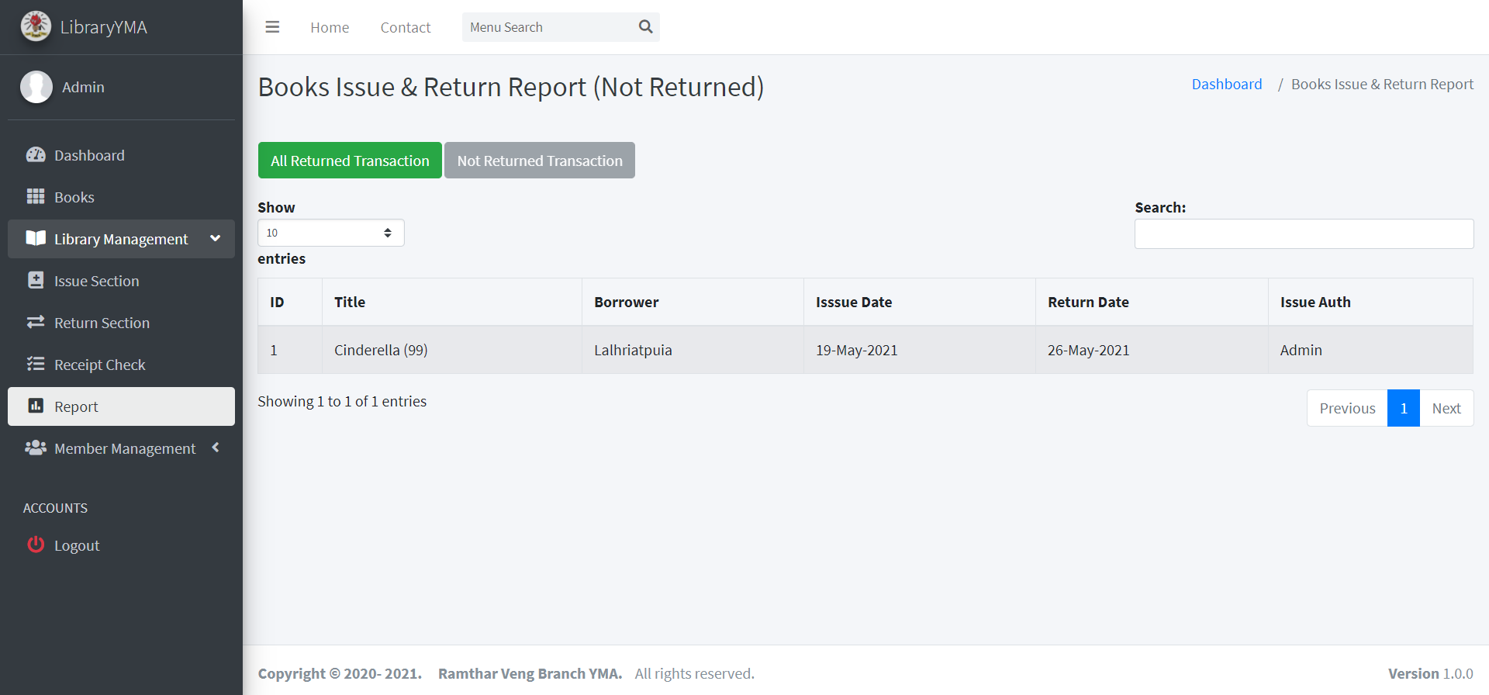

**BACK UP**

Back Up is used to backup all the data that is running and used in this software. There is a situation where there is an error or breakdown of a PC and might sometime need to reset all its content, in such situations this back up files is what you need to restore and continue to work with smoothly. When you click on the Database Menu, it will show Back Up Menu, you have to wait for sometimes (around 1 to 2 minutes depending on number of data stores in the system) to prompt the success message.

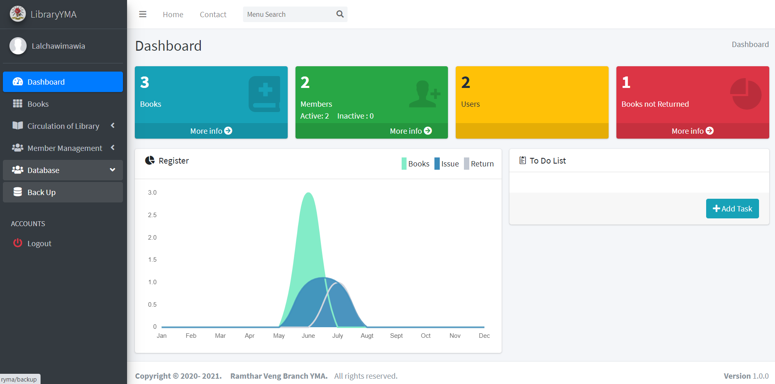

You can click Back Up menu from any page, when you click you will notice that in the page tab there is a loading symbol which means that backing up of data is still in progress. Within this time, do not click any link or refresh or back, if do so; **it will cancel the back up process**.

Upon successful back up of data, the Success Message pop up will appear and this back up will be stored in wamp folder e.g. D:\wamp64\www\project\storage\app\backups\Laravel.

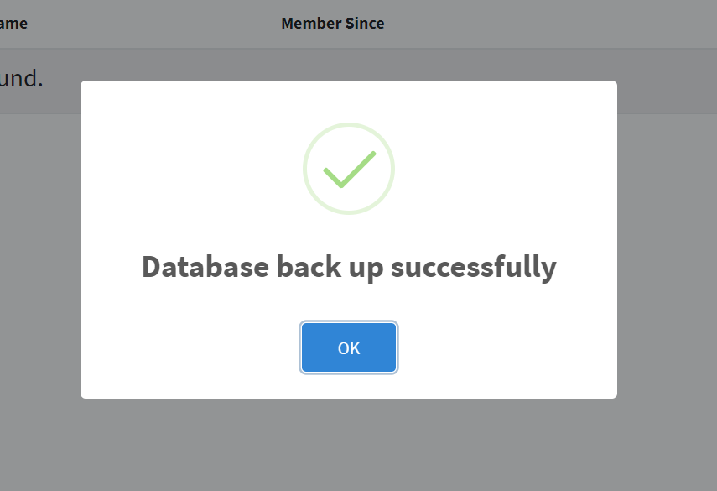

This can be breakup as:

**D**-> it is the Drive where software install.

**wamp64**-> it is the main folder of the server.

**www**->it is the content of all the project of a server.

**project**->it is the name of the project, main folder of a software.

**storage**->It is a sub-folder of Project.

**app**->It is a sub-folder of storage folder.

**backups**->It is a sub-folder of app folder.

**Laravel**->It is a sub-folder of backups folder. This folder contains the database backup files in compressed format named by its date and time when it backups the data.

In case of severe difficulties faced by the PC, it is suggested this backup file are to be stored in other places like pendrive, external hard drive, other PC, Google Drive, etc.

It is also suggested to delete old backup files as this files can occupy large amount of storage space.

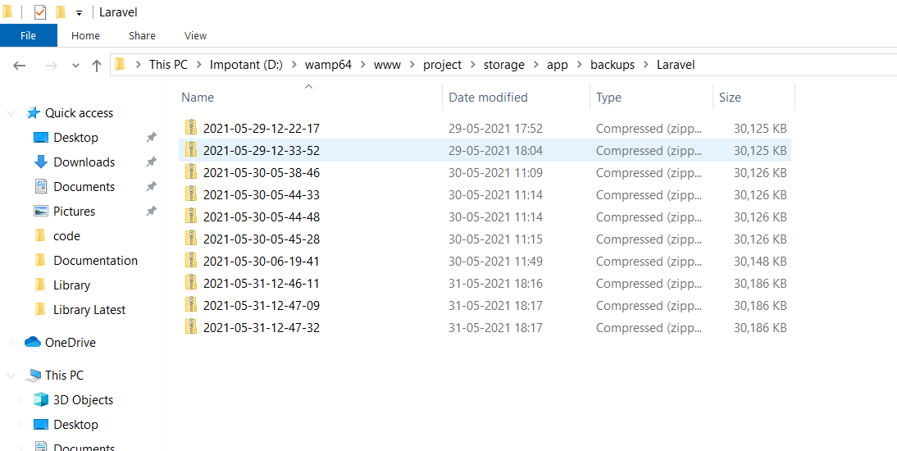

**SETTINGS**

The settings menu is available only for the privilege users i.e who have the administrator role. The users registers through the system register module using the system secret code are assign as administrator.

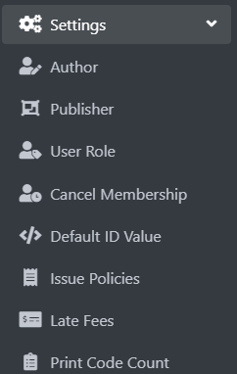

1. **Author** : The author module is used to add, edit and delete the author.

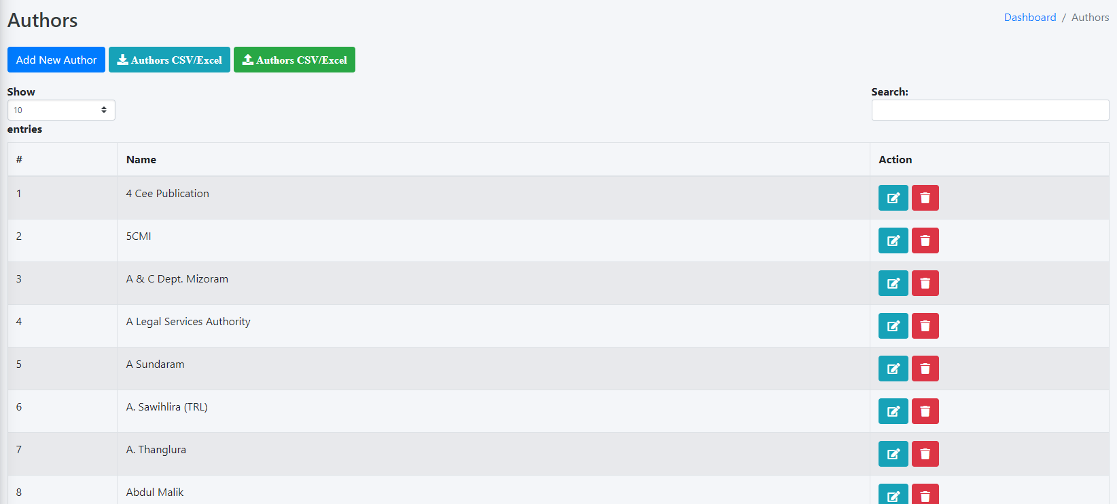

You can import and export the authors using the **Authors CSV/Excel** (pacific blue color) for export and the **Authors CSV/Excel** (green color) for import. If the book database have authors_id as 0, then the sync yellow button will appear and will sync when click.

1. **Publisher** : The publisher module is used to add, edit and delete the publisher.

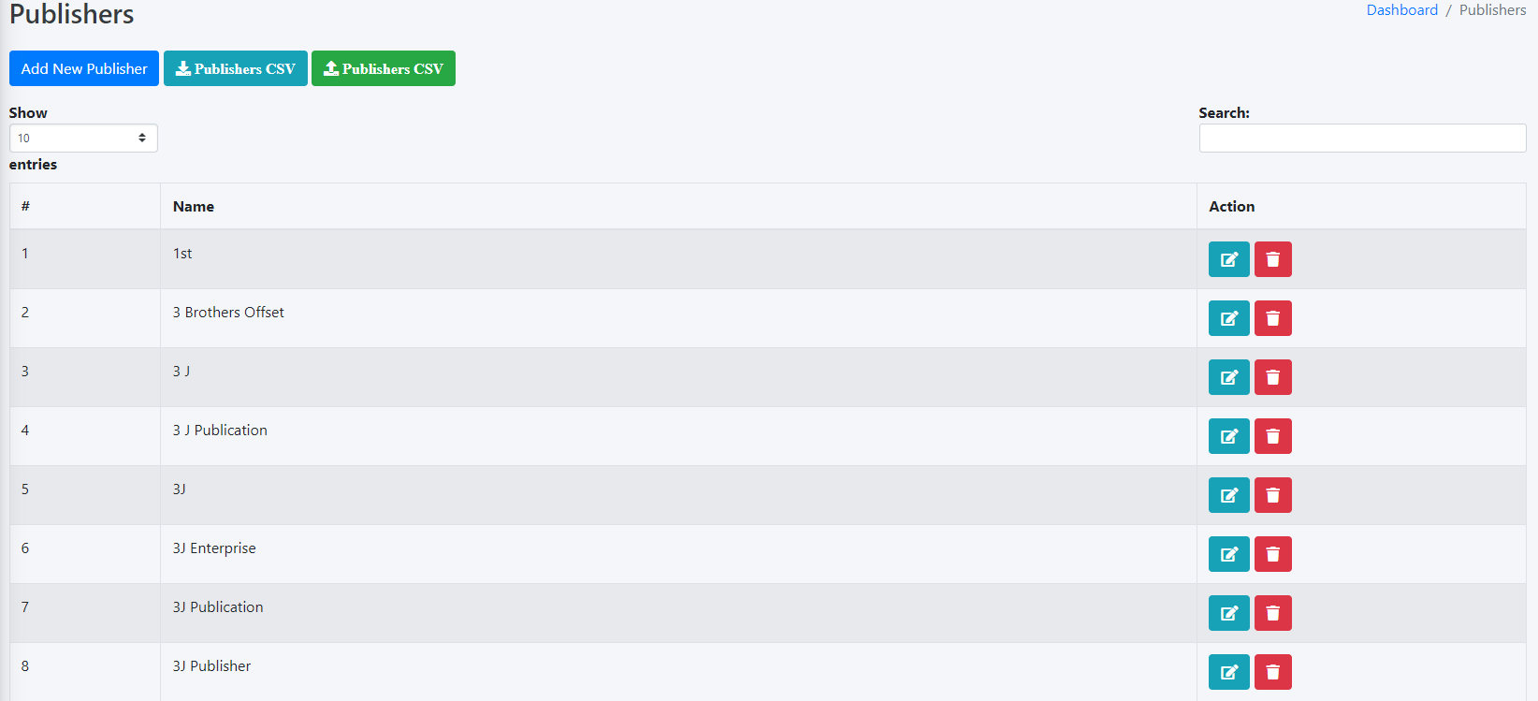

You can import and export the authors using the **Publishers CSV/Excel** (pacific blue color) for export and the **Publishers CSV/Excel** (green color) for import. If the book database have publisher_id as 0, then the sync yellow button will appear and will sync when click.

1. **User Role** : The user role module is used to assign a user an administrator role or not just by selecting the checkbox.

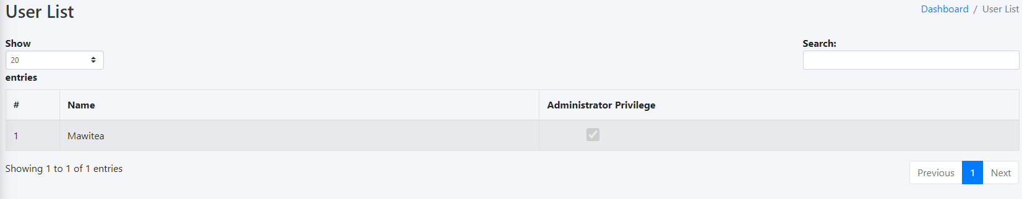

1. **Cancel Membership** : The cancel membership module is used to deactivate the member right away by clicking the **Deactivate Membership** button.

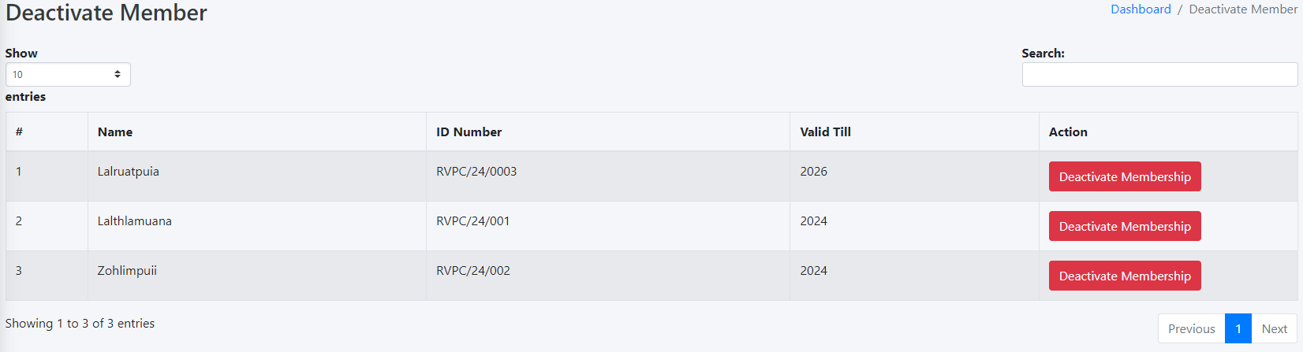

1. **Default Id Value** : This module is used to assign a default value for a members.

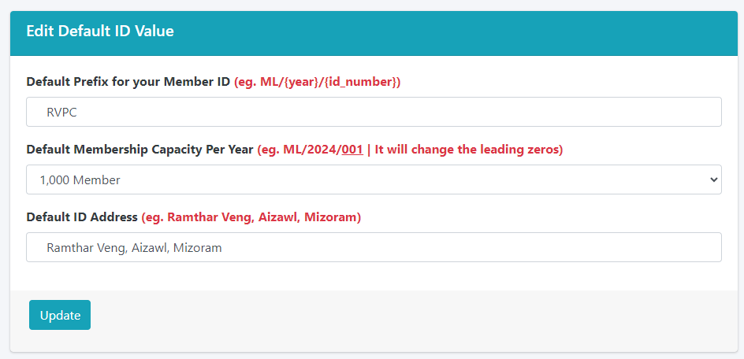

1. **Issue Policies** : This module is used to set the limit number of books allowed to be borrowed by a member and a duration of a loan period borrowed which will affect upon update.

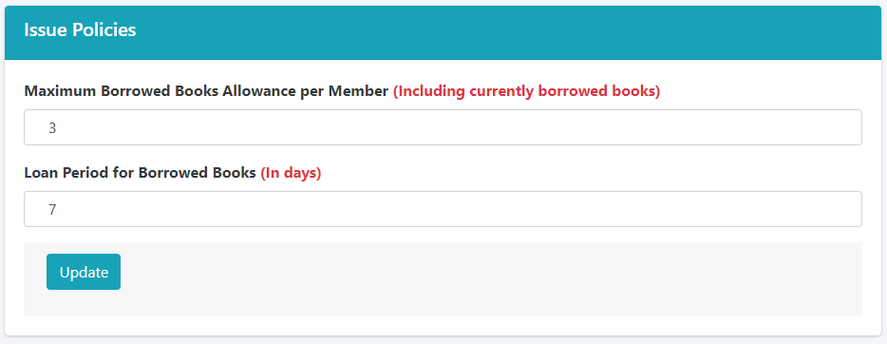

1. **Late Fees** : This module is used to set Late fees regarding borrowed books.

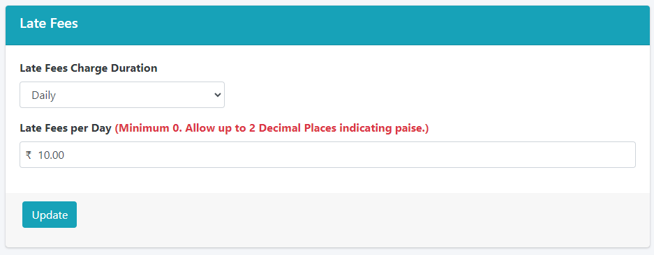

1. **Print Code Count** : This module is used to set the number of barcode counts when printing in a page.

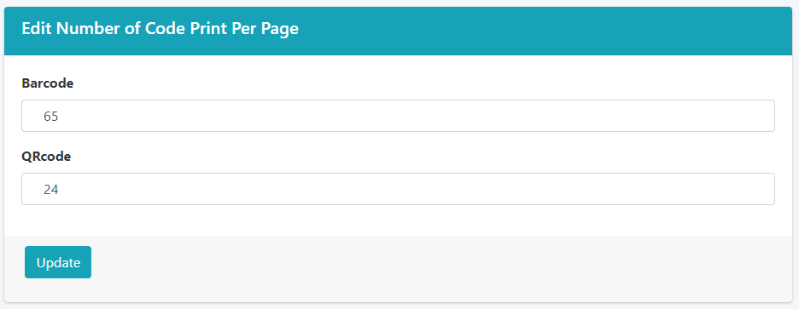

**EXTRA NOTES**

1. To install a software in new machine, you have to follow the steps below (Internet connection might be required):
2. Install these software (recommended as other same software might be available):

Wamp Server 64 bit : <https://www.wampserver.com/en/>

Git Bash : <https://git-scm.com/downloads>

Composer : <https://getcomposer.org/download/>.

1. Copy and paste the main folder of a software to wamp64/www/ .
2. Create database named : **library** in MySQL.
3. Open Git Bash pointing to the directory of main folder of the software i.e wamp64/www/project just by opening the folder and Right Click and open Git Bash from the Right Click Menu list.
   1. **Re-configure composer**: This require internet connection, you can skip but it is recommended. This will refresh the composer dependencies of your current project by running the composer command.

***composer install***

* 1. **Generate new key**: Generating fresh key to application by running the artisan command.

***php artisan key:generate***

* 1. **Clear the cache:** This will clear the cache of previous work experience, route etc. just by running the artisan command.

***php artisan cache:clear***

* 1. **Migration of database**: You have to insert a table to your database created. To do this, run the artisan command.

***php artisan migrate***

* 1. **Seeding database**: You have to insert the required value to database you have created. To do this, run the artisan command.

***php artisan db:seed***

* 1. **Link the media**: In order to work properly with all the graphics, you have to delete the existing folder of storage under wamp64/www/project/public/ . If you find storage folder, delete it. If not found, then you can run the command.

***php artisan storage:link***

1. To access the software from other Local PC’s or Mobiles, you can run the command in the command line interface such as Command Prompt, Git Bash, etc.

Command : php artisan serve --host=192.168.1.7 --port=8000

Here, you have to change the host IP i.e 192.168.1.7 as your machine IP which you can check it from **ipconfig** command. To run the command, you have to install Composer in your system.

After successfully run the command, you can connect the Library software from your PC and Mobile just by entering the host IP to your PC or mobile browser. You have to make sure that the connection of internet is from the same router or the same line i.e. all the system must connect to the same network.

1. Sometimes you may find the image or graphic do not show properly. In that case, you have to delete the shortcut folder of ***storage***: **wamp64\www\project\public\storage**.

After delete, open the Command prompt, Git Bash, etc.

Run the command: **php artisan storage:link**

After that, all the graphics will be automatically fixed.

1. After installing a software, it is recommended that you change the setting of a MySQL password system by :
2. Open Wamp server.
3. Left Click on local server logo (located in taskbar, right side, it might be hidden)
4. Point to MySQL to show the menu.
5. Then, click on the MySQL Console.
6. The default password in not set, so press Enter Key when asked. (Password might be different if changed by the user).
7. Enter this command to the console : **alter user 'root'@'localhost' password expire never;**
8. Press Enter key and you are set.
9. If Backup is not working properly, try checking the settings of a database.php file located in: project/config/database.php. Then, search for mysql array, and change to the line relating :

***'dump_binary_path' => 'D:\wamp64\bin\mysql\mysql8.0.18\bin',***

as required. Notice the Drive given and the drive where your server install.

--END--